BLADDER CANCER  Blood cancer is one of the most common types of cancer that starts in the bladder cells. The disease mostly begins in the urothelial cells that line the side of the bladder. the urothelial cells are primarily located in the ureters and the kidney  symptoms  significant signs and symptoms of bladder cancer include  - back pain  - frequent urination  - hematuria (blood in the urine) results in the urine color appearing cola or red-colored.  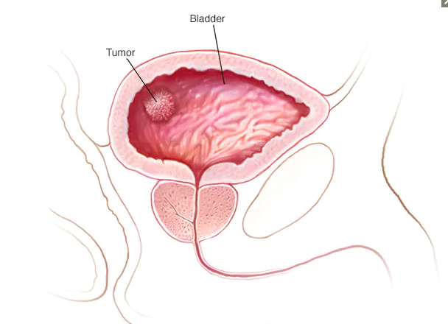  - Painful urination | SAY NO TO BLADDER CANCER  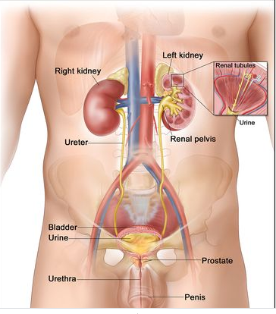 |  | 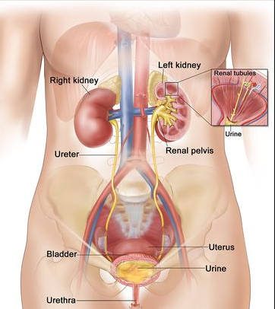
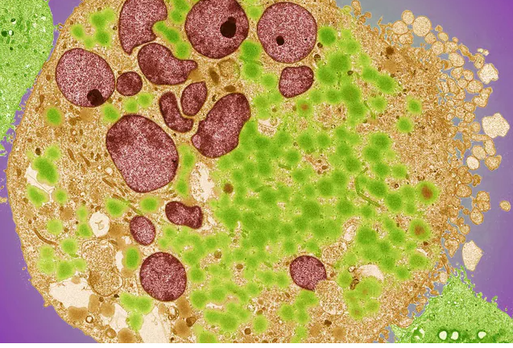 |  | TYPES OF BLADDER CANCER  Adenocarcinoma  This type of cancer starts in the cells that constitute the mucus-secreting glands.  Urothelial carcinoma  This type of bladder cancer occurs in the cells that line the sides of the bladder. The urothelial cells contract when the bladder is empty and expands when the bladder is full.  Squamous cell carcinoma cancer is linked with chronic irritation in the bladder. |  |  | Risk factors  - Family history of cancer  - Previous cancer treatment  - Chronic bladder infection  - Increasing age  - Smoking    - Exposure to specific chemicals
CAUSES  Bladder cancer starts when the cell in the bladder undergoes mutation in its DNA. the abnormal cells form a tumor that destroys and invades the normal body tissues. |  | Prevention  Choose a variety of vegetables and fruits.  A diet rich in antioxidants helps in the reduction of the risk associated with cancer.  Avoid smoking  Take precaution when handling chemicals |  |  | CUSTOMER SUPPORT  Helpline 1:  Helpline 2:  Email:

